|  |
| --- |
| Functional test cases -  I2 |
| DMS H7 |

|  |
| --- |
| Test Scenarios – I2  May 2021 |
|  |

# Document version

|  |
| --- |
|  |
| Document version:   |  |  |  |  | | --- | --- | --- | --- | | Version nr. | Dato | Created by | Updates | | 1.0 | 11-05-2021 | Emma Hagerup |  | |

Table of Content

1 Document version 1

2 Introduction 3

2.1 Test data and preconditions 3

2.2 Process flow 3

2.3 Test Scenarios 3

3 Detailed test scenarios 5

3.1 Scenario 1: I2 presentation notification rejected based on content validation 5

3.2 Scenario 2: I2 presentation notification with notification of acceptance 6

# Introduction

The purpose of this test is to ensure that the Economic Operator (EO) can successfully submit a presentation notification, otherwise known as an I2. An I2 is sent by the EO to the DMS ERMIS system. A declarant can submit an I2 declaration when presenting goods from an earlier submitted pre-lodged declaration.

## Test data and preconditions

To be able to do execute the functional test cases for amendment, the EO must have established a connection to the DMS test system, following the Connectivity Guide. Second, the EO must send a declaration followed by an amendment. This must be done using the following services:

* DMS.Import.Declaration.Submit
* DMS.Import.Declaration.Amend.Goodspresented

To endpoint:

* https://secureftpgatewaytest.skat.dk:6384/exchange/CVR_<CVR>_UID_<UID>

## Process flow

The process flow for delivering a presentation notification for an already existing declaration can be seen in Figure 1 below.

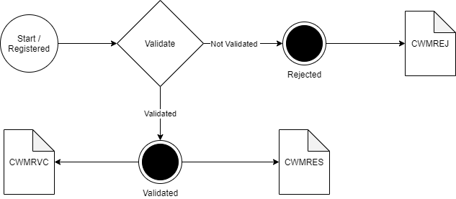

Figure 1

## Test Scenarios

To complete the functional onboarding phase two, the OE must deliver confirmation of passed test-cases for each test scenarios:

|  |  |  |
| --- | --- | --- |
| **Test no** | **Test Scenario** | **Passed** |
| **1** | Send I2 presentation notification which is rejected based on content validation. | ☐ |
| **2** | Send I2 presentation notification and receive notification of registered I2 presentation notification. | ☐ |

Figure 2 shows the process flow divided into the above mentioned 2 scenarios.

Figure 2

# Detailed test scenarios

The following sections will describe the aim of the specific test scenarios and it will provide the desired results of the test. It should be noted that there can be changes in the notifications provided by the DMS solution, because the solution is still in development. If at a later point more notifications will be added the EO will be informed about this and the EO will be requested to complete the test again.

## Scenario 1: I2 presentation notification rejected based on content validation

The following sections will describe the aim of the test and it will provide the relevant test data and results of the test.

The aim of scenario 1 is to test if the EO can obtain notification that the I2 presentation notification has been rejected.

**Success**

A notification has been successfully applied for and received.

**Test data example**

The following test data should be used:

* Submit initial H7 declaration: *IMD.xml* (remember to fill in LRN)
* Test for wrong content by sending an I2 presentation notification with changes in fields where it is not allowed:

From:

<ns2:GoodsMeasure>   
 <ns2:GrossMassMeasure>1.5</ns2:GrossMassMeasure>   
</ns2:GoodsMeasure>

To:

<ns2:GoodsMeasure>   
 <ns2:GrossMassMeasure>2.5</ns2:GrossMassMeasure>   
</ns2:GoodsMeasure>

* Fill in the content error XML: *I2_scenario_1.xml* with preferred LRN and assigned MRN and submit the XML.
* Pull notification to see the notification of rejection.

## Scenario 2: I2 presentation notification with notification of acceptance

The following sections will describe the aim of the test and it will provide the relevant test data and results of the test.

The aim of scenario 2 is to test that the EO can obtain notification that the I2 presentation notification has been received.

For the test to succeed the EO should be able to receive notifications about acceptance of the I2 presentation notification.

**Test data example:**

The following test data should be used:

* Submit initial H7 declaration: *IMD.xml* (remember to fill in LRN)
* Fill in the correct I2 XML: *I2_scenario_2.xml* with preferred LRN and assigned MRN and submit the XML.
* Pull notification to see the notification of granted request.

#Decorative

|  |  |  |  |
| --- | --- | --- | --- |
|  | www.ufst.dk  ISBN |  | Udviklings- og Forenklings- styrelsen er en del af  Skatteforvaltningen |